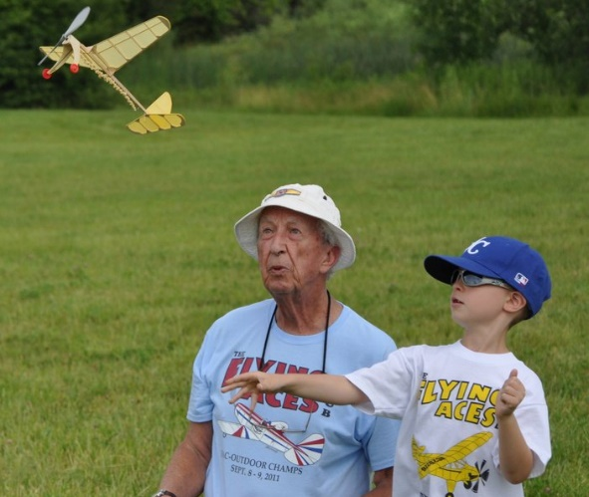

**Sponsored By: historicnewengland.org**

**Stealth Squadron**

**Free Flight Model Airplane Club Fun Fly!**

**11am – 2pm, June 14th 2025!**

**Spencer Peirce Little Farm, Newbury, Ma.**

**Come and join us and see what we’re all about!**

* **Demonstration Flights including Timed Events and Mass Launches!**

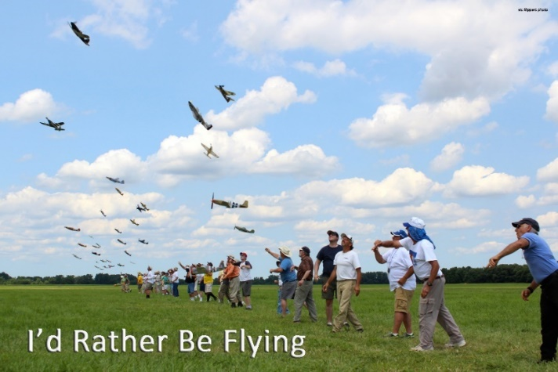

* **World War 1 Mass Launch at 12 noon**
* **World War 2 Mass Launch at 12:30 pm**
* **National Air Race Mass Launch at 1:30 pm**
* **Timed events throughout the day**
* **Building and trimming tips!**

$5 Admission, includes model airplane! (while supplies last)

<https://my.historicnewengland.org/20312/flying-aces>

**Location: Spencer Peirce Little Farm, 5 Little’s Lane, Newbury, Ma.**

**Contact:**